SHERLOCK HOLMES

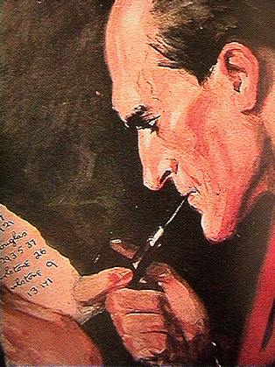

221b Baker Street. Mr. Sherlock Holmes, and his colleague John H. Watson, M.D., spent many years at this address in London, England, under the rent of Mrs. Hudson. Characters of every type have frequented the rooms of this place, calling on Mr. Holmes for help and assistance on mysteries only the finest criminal detective could unravel.
Sherlock Holmes, the amateur detective, chemist, violin player, boxer, and swordsman (among other talents), first appeared in Sir Arthur Conan Doyle's A Study in Scarlet in the Beeton's Christmas Annual in 1887.
Master Detective and role model to many, Sherlock Holmes has solved many problems that others could never dream of solving. He would never take a case that was not unusual or fantastic. Then he would use his incredible mind to solve cases in a logical manner. It is well known that Holmes is a man who loved his sleep, coffee, tobacco, and cocaine. In the stories, Holmes is described as over six feet tall with a skinny face, thin lips, and penetrating gray eyes.
Conan Doyle wanted a dramatic finish for the great Sherlock Holmes.
In 1893 Conan Doyle visited Reichenbach Falls in the northern Swiss Alps. After seeing the magnificent falls he decided the place would make a worthy tomb for Sherlock Holmes.
The Adventure of the Final Problem was published in December of 1893 in the Strand Magazine. People were so upset that more than twenty thousand of them cancelled their subscription to the Strand Magazine.
His possessions are : his deerstalker, magnifying glass, calabash pipe, violin, chemistry equipment, notebook, Persian slipper and disguises.

Ask questions corresponding to the underlined words in the text (10 questions)

